Project Coversheet
Full Name | Augustine Cudjoe
Project Title (Example – Week1, Week2, Week3, Week 4) | Customer Sign-Up Behaviour & Data Quality Audit  Week1
Instructions:
Students must download this cover sheet, use it as the first page of their project, and then save the entire document as a PDF before submission.
Project Guidelines and Rules
1. Formatting and Submission
- Format: Use a readable font (e.g., Arial/Times New Roman), size 12, 1.5 line spacing.
- Title: Include Week and Title (Example - Week 1: Travel Ease Case Study.)
- File Format: Submit as PDF or Word file
- Page Limit: 4–5 pages, including the title and references.
2. Answer Requirements
- Word Count: Each answer should be within 100–150 words; Maximum 800–1,200 words.
- Clarity: Write concise, structured answers with key points.
- Tone: Use formal, professional language.
3. Content Rules
- Answer all questions thoroughly, referencing case study concepts.
- Use examples where possible (e.g., risk assessment techniques).
- Break complex answers into bullet points or lists.
4. Plagiarism Policy
- Submit original work; no copy-pasting.
- Cite external material in a consistent format (e.g., APA, MLA).
: Clear grasp of business analysis principles.
- Application: Effective use of concepts like cost-benefit analysis and Agile/Waterfall.
- Clarity: Logical, well-structured responses.
- Creativity: Innovative problem-solving and examples.
- Completeness: Answer all questions within the word limit.
6. Deadlines and Late Submissions
- Deadline: Submit on time; trainees who fail to submit the project will miss the “Certificate of Excellence”
7. Additional Resources
- Refer to lecture notes and recommended readings.
- Contact the instructor or peers for clarifications before the deadline.
YOU CAN START YOUR PROJECT FROM HERE

Week 1 Project

Customer Sign-Up Behaviour & Data Quality Audit

Rapid Scale — Business Intelligence Team
Dataset: customer_signups.csv | support_tickets.csv Period: January 2024 – October 2024 | n = 300 records

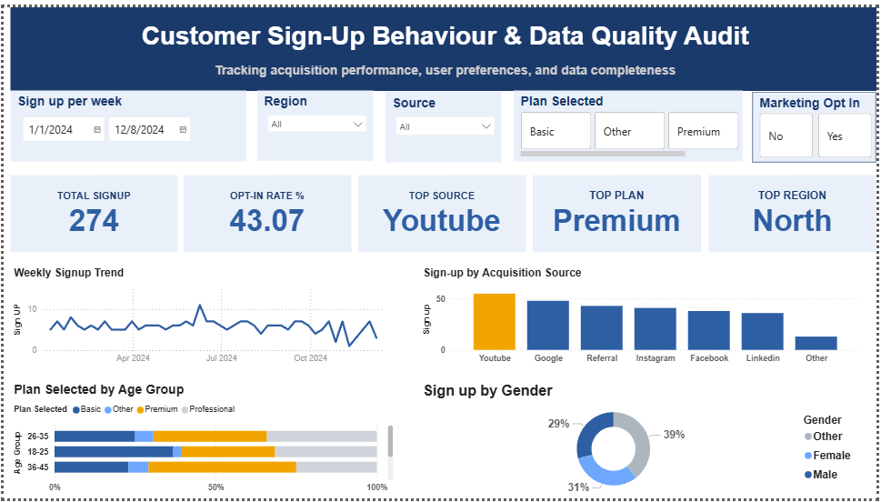

3.1 Sign-ups per week (grouped by signup_date)

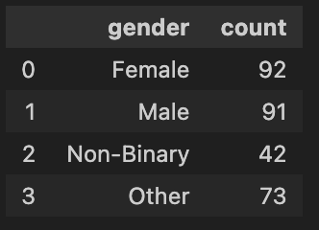

3.4 Age summary: min, max, mean, median, null count

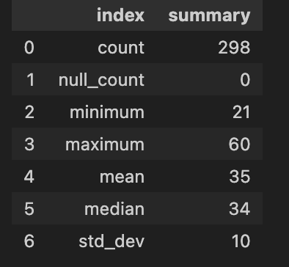

SECTION 4

Business Question Answers
Q1 Which acquisition source brought in the most users last month?

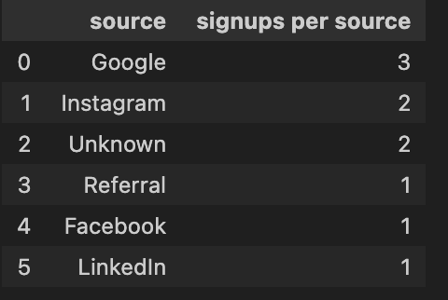

Q2 — Which region shows signs of missing or incomplete data?

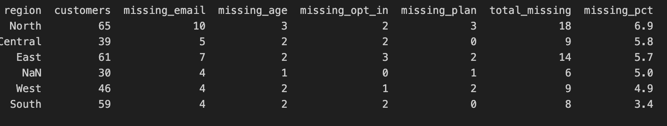

Q3 — Are older users more or less likely to opt in to marketing?

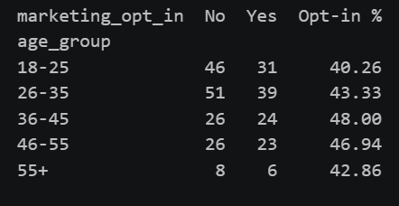

Q4 — Which plan is most commonly selected, and by which age group?

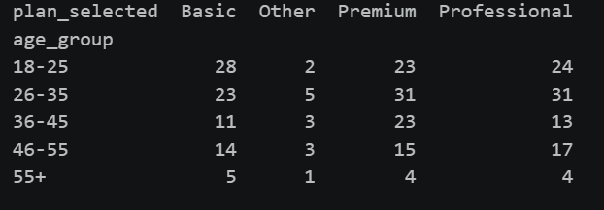

Q5 (Optional) — Which plan's users are most likely to contact support?

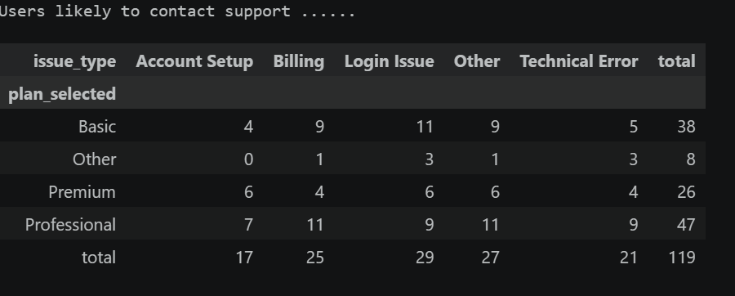

OPTIONAL STRETCH TASK — SUPPORT TICKET ANALYSIS
Q1.Count how many customers contacted support within 2 weeks of sign-up
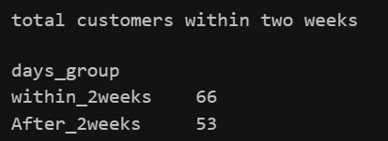

Q2. Summarise support activity by plan and region (Group by plan and region)

